Analysis of Crime & Poverty in Washington During 2017

Report

Student:

Pooja Nagrecha, Ryan Thomas, Ana Gill & Chris Krokus

# Crime Dataset: Exploration

During the initial exploration of the Crime Dataset, the following steps were taken:

* Overview of dataset
  + Reviewing the initial condition of the dataset
  + Isolate the columns that possible contain meaningful data
  + Identify common data in both the Crime & Poverty Dataset
* Cleaning the data
  + Rename columns for easier data manipulation
  + Identifying any missing fields
  + Assigning fields to their appropriate data types
* Creating Visualizations
  + Investigate trends in crime over time
  + Investigate distribution of crime over a geographic space
  + Review the various types of offenses and weapons
* Preliminary Statistical Analysis
  + Confirm whether any of the data presents a normal distribution
  + Explore possible correlations within the dataset
  + Complete Chi-square Analysis

# Overview of Dataset

After renaming the columns with more manageable names, the following summary of the dataset was available:

<class 'pandas.core.frame.DataFrame'>

RangeIndex: 33082 entries, 0 to 33081

Data columns (total 23 columns):

# Column Non-Null Count Dtype

--- ------ -------------- -----

0 CCN 33082 non-null int64

1 Report 33082 non-null object

2 Shift 33082 non-null object

3 Method 33082 non-null object

4 Offense 33082 non-null object

5 Block 33082 non-null object

6 XBlock 33082 non-null int64

7 YBlock 33082 non-null int64

8 Ward 33082 non-null int64

9 ANC 33082 non-null object

10 District 33079 non-null float64

11 PSA 33079 non-null float64

12 Neighborhood 32712 non-null object

13 Block_Grou 32998 non-null object

14 Census_Trac 32998 non-null float64

15 Voting_Precinct 33082 non-null object

16 Latitude 33082 non-null float64

17 Longitude 33082 non-null float64

18 Bid 5830 non-null object

19 Start_Date 33082 non-null object

20 End_Date 31585 non-null object

21 Object_ID 33082 non-null int64

22 Octo_Recor 33082 non-null object

dtypes: float64(5), int64(5), object(13)

memory usage: 5.8+ MB

The following observations were made:

* Many fields represented geographical information (e.g. XBlock, YBlock, Ward, District, Neighborhood, Block Groc, Census Tract, Voting Precinct, Longitude & Latitude)
* With respect to time, Shift reported on whether crimes occurred in the morning or evening. More importantly, Start_Date and End_Date captured a timestamp of when incidents took place. This two timestamps were originally typed as strings and would need to be modified to create time series plots.
* Method reported on the weapon used in committing the crime
* Offense detailed the various types of crime

|  |  |
| --- | --- |
| **Type of Crime** | **Frequency in 2017** |
| THEFT/OTHER | 8170 |
| THEFT F/AUTO | 5538 |
| MOTOR VEHICLE THEFT | 1692 |
| ROBBERY | 1494 |
| ASSAULT W/DANGEROUS WEAPON | 1405 |
| BURGLARY | 1025 |
| SEX ABUSE | 194 |
| HOMICIDE | 94 |
| ARSON | 3 |

This column features various types of theft and there was thought given to merging categories. Although there are THEFT F/AUTO and MOTOR VEHICLE THEFT, one may reference a theft involving a vehicle whereas the other is likely theft of a vehicle. Similarly, ROBBERY is theft of personal property and BURGLARY involves entering a building to commit theft. There was sufficient distinction to leave this categories independent.

* Census_Tract information was present in both datasets. This is a geographical area defined for the purpose of taking a census.

# Cleaning the Data

## Identify Missing Data

Referencing the Pandas output above, the dataframe contained **33082** rows. However, the highlighted fields contained some missing fields.

|  |  |  |  |  |
| --- | --- | --- | --- | --- |
| **#** | **Column** | **Non-Null** | **Count** | **Dtype** |
| 0 | CCN | 33082 | non-null | int64 |
| 1 | Report | 33082 | non-null | object |
| 2 | Shift | 33082 | non-null | object |
| 3 | Method | 33082 | non-null | object |
| 4 | Offense | 33082 | non-null | object |
| 5 | Block | 33082 | non-null | object |
| 6 | XBlock | 33082 | non-null | int64 |
| 7 | YBlock | 33082 | non-null | int64 |
| 8 | Ward | 33082 | non-null | int64 |
| 9 | ANC | 33082 | non-null | object |
| 10 | District | 33079 | non-null | float64 |
| 11 | PSA | 33079 | non-null | float64 |
| 12 | Neighborhood | 32712 | non-null | object |
| 13 | Block_Grou | 32998 | non-null | object |
| 14 | Census_Trac | 32998 | non-null | float64 |
| 15 | Voting_Precinct | 33082 | non-null | object |
| 16 | Latitude | 33082 | non-null | float64 |
| 17 | Longitude | 33082 | non-null | float64 |
| 18 | Bid | 5830 | non-null | object |
| 19 | Start_Date | 33082 | non-null | object |
| 20 | End_Date | 31585 | non-null | object |
| 21 | Object_ID | 33082 | non-null | int64 |
| 22 | Octo_Recor | 33082 | non-null | object |

Columns Bid and End_Date were not used in the analysis. With respect remaining columns with missing data, an appropriate value was found to fill the missing fields. In most cases, this was the median() value.

## Assign Appropriate Data Types

* Start_Date was converted to a timestamp using the following command

df['Start_Date'] = pd.to_datetime(df['Start_Date'], format='%Y-%m-**%d**T%H:%M:%S.**%f**')

# Creating Visualizations

## Investigate Trends in Crime over Time

Using the timestamps in Start_Date, it was now possible to:

* create a time series of different types of crime over time

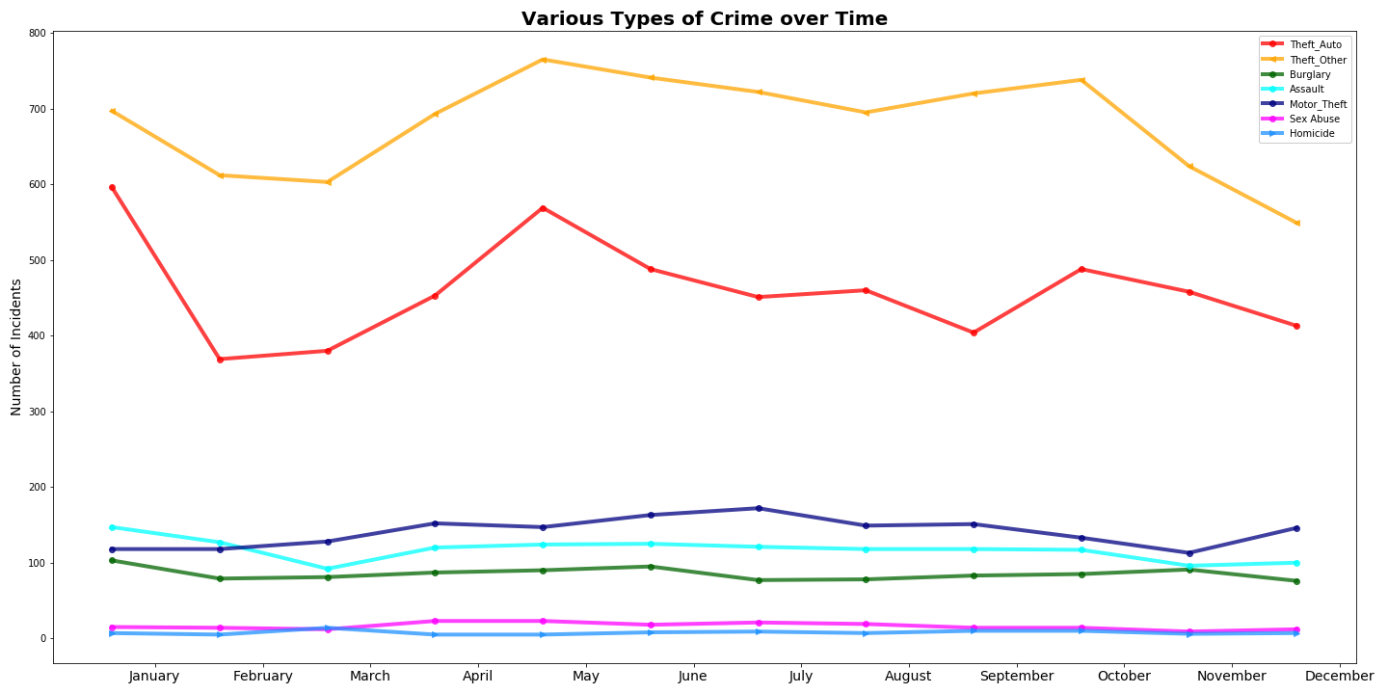

* aggregate incidence of crime over different periods (e.g. time of day, weekdays, month and year

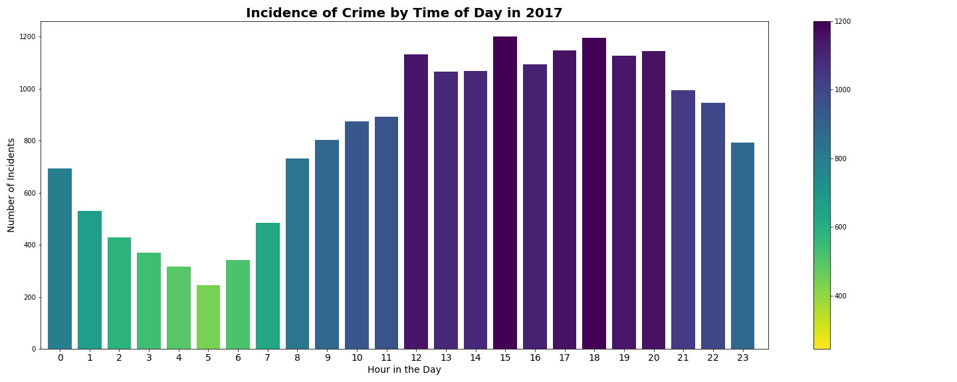

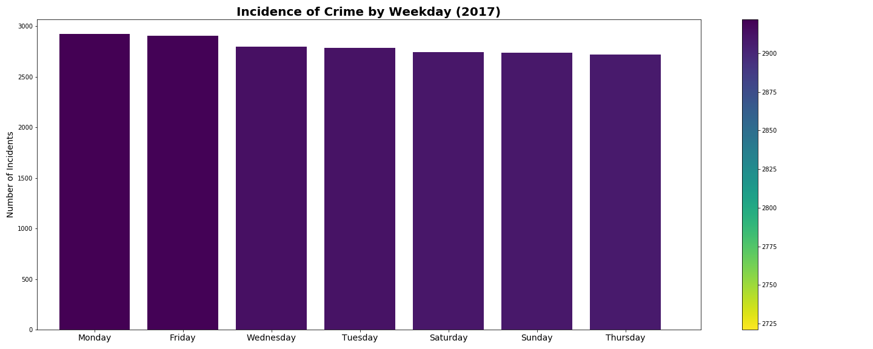

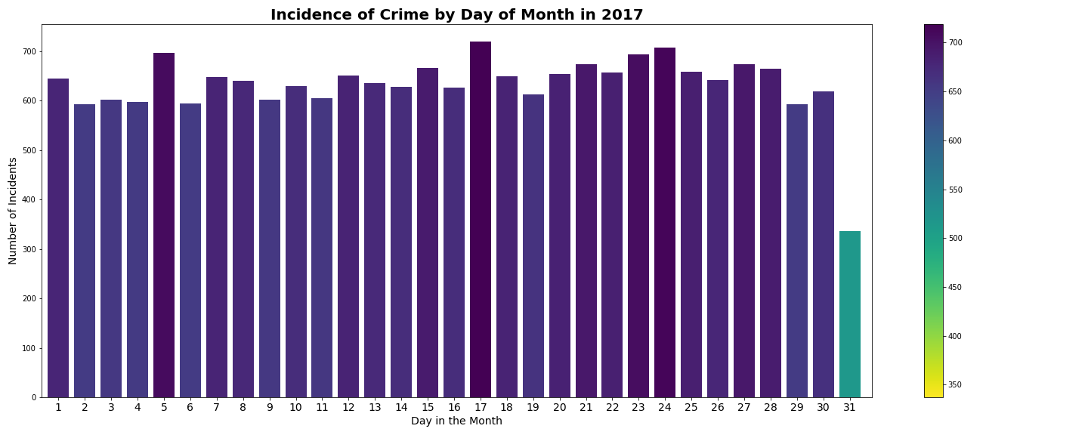

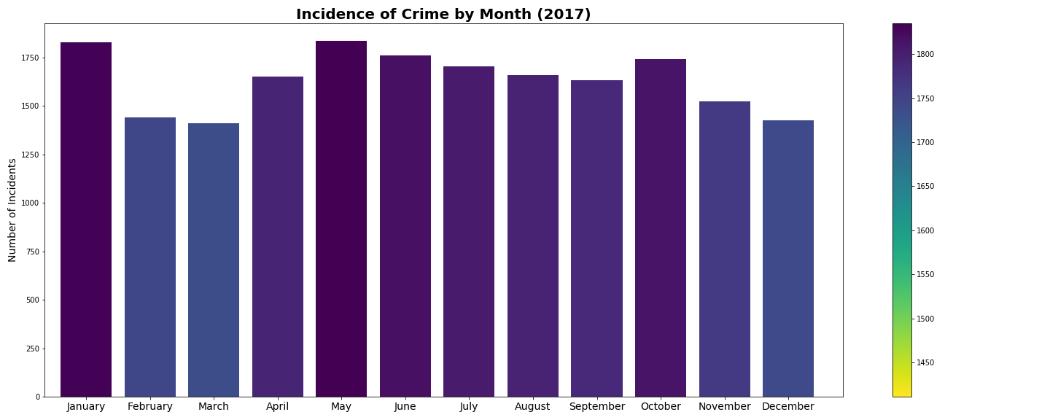

It was found that Homicide, Sex Abuse, Assault, Burglary and Motor Theft remainder fairly consistent throughout the year. However, Theft_Auto and Theft_Other demonstrated more range with peaks in January and April 2017.

With respect to looking at the total volume of crime during the year, the incidence of crime remains relatively steady during the week, Over the course of the month, only the 31st day illustrated a significant drop and this like due to only 7 months having 31 days. Reviewing variations in crime during the day, it was observed that most incidents took place between 3pm and 6pm.

## Investigate Distribution of Crime over Washington

Leveraging Latitude and Longitude fields in the dataset, a Google Maps heatmap was generated to illustrate the distribution of crime over the Washington area. It can be seen that high volumes are crime are concentrated on the city center.

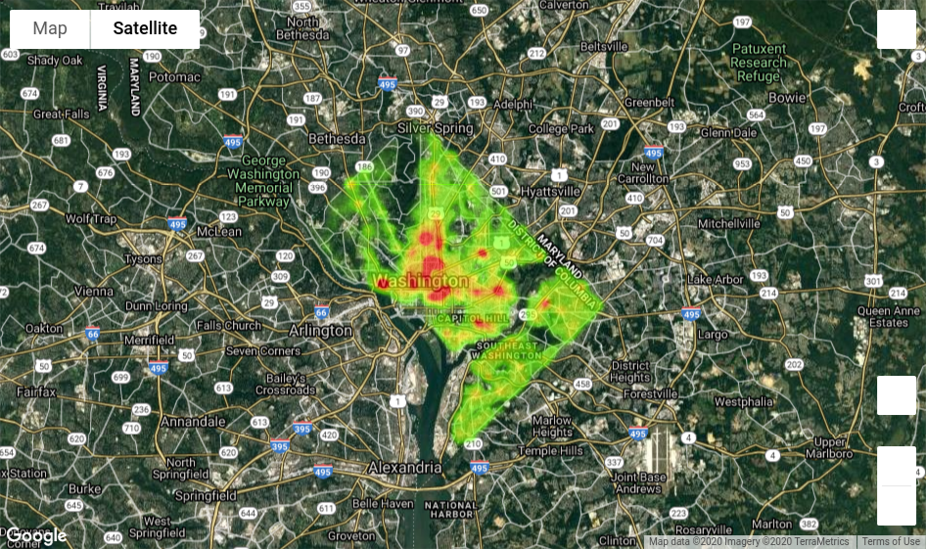

## Types of Weapons

Method was not an insightful field. This datapoint lacked granularity with more than 90% of the data being uncategorized.

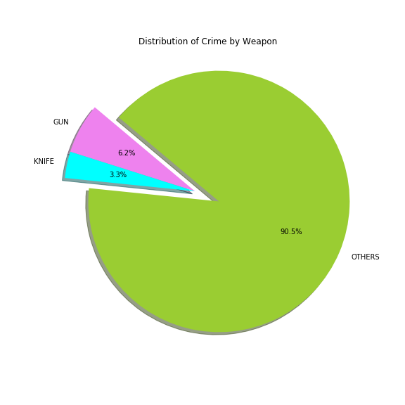

## Bar Charts

Below are chart illustrating:

* top 10 census tracts
* total number of offenses by type
* total number of offenses by method

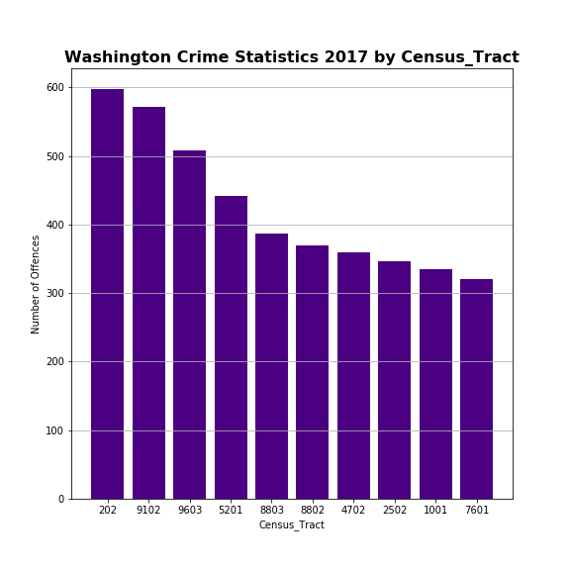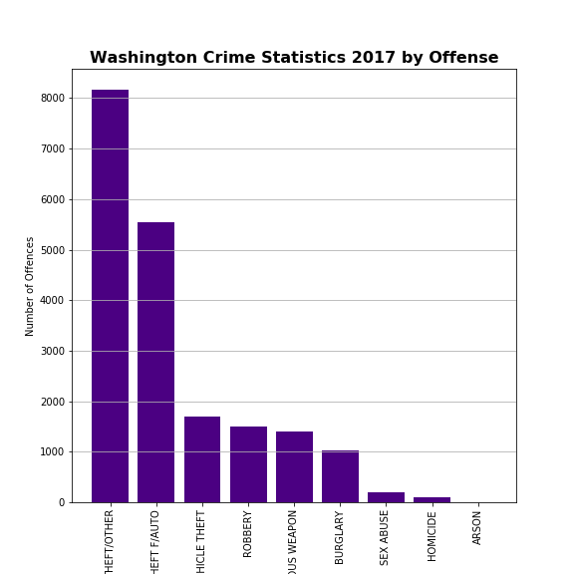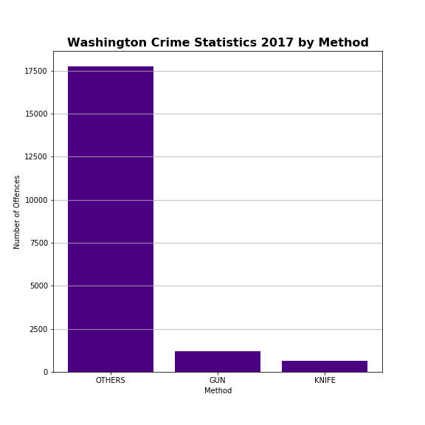

# Preliminary Statistical Analysis

## Histograms

Histograms were generated for each field to confirm the nature of the distribution. None of the columns were found to demonstrate a normal distribution

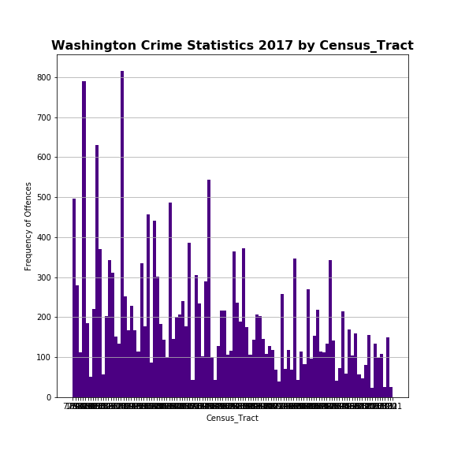

## Scatter Plots

Various scatter plots were generated and did not highlight any correlation between columns.

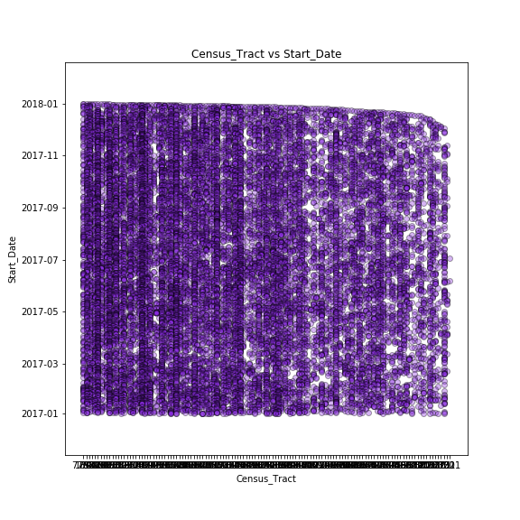

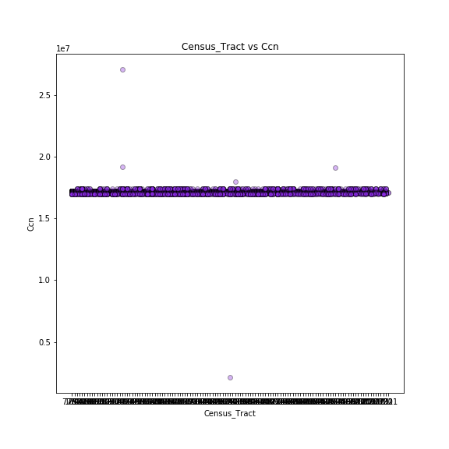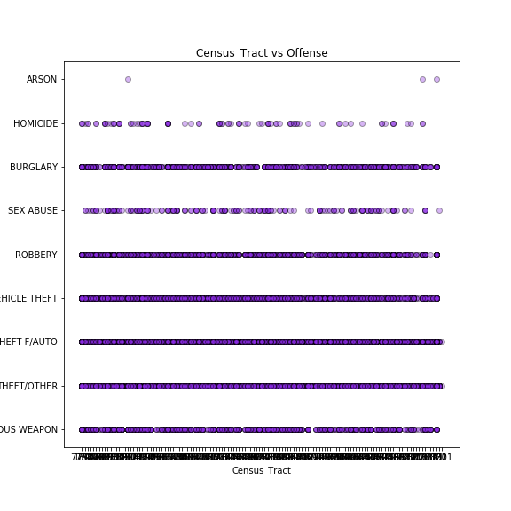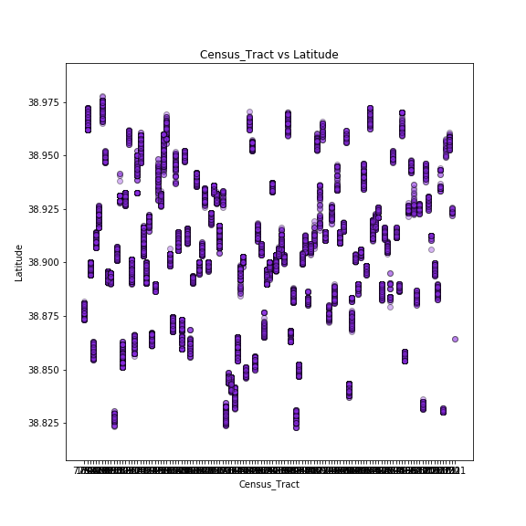

## Correlation

As highlighted previously, a large portion of the dataset represented geographic information. No meaning correlation was observed.

|  |  |  |  |  |  |  |  |  |  |  |
| --- | --- | --- | --- | --- | --- | --- | --- | --- | --- | --- |
| **CCN** | **XBlock** | **YBlock** | **Ward** | **District** | **PSA** | **Census_Trac** | **Latitude** | **Longitude** | **Object_ID** | **Column1** |
| CCN | 1 | -0.023778 | 0.013871 | -0.027237 | -0.023326 | -0.023277 | -0.015033 | 0.013869 | -0.023775 | -0.137417 |
| XBlock | -0.023778 | 1 | -0.431536 | 0.731881 | 0.627243 | 0.627632 | 0.662248 | -0.431537 | 1 | 0.077595 |
| YBlock | 0.013871 | -0.431536 | 1 | -0.604422 | -0.339318 | -0.342631 | -0.521944 | 1 | -0.431603 | -0.037003 |
| Ward | -0.027237 | 0.731881 | -0.604422 | 1 | 0.576764 | 0.57667 | 0.582619 | -0.604424 | 0.731845 | 0.062215 |
| District | -0.023326 | 0.627243 | -0.339318 | 0.576764 | 1 | 0.999924 | 0.398355 | -0.339336 | 0.627175 | 0.075858 |
| PSA | -0.023277 | 0.627632 | -0.342631 | 0.57667 | 0.999924 | 1 | 0.399889 | -0.342648 | 0.627565 | 0.075729 |
| Census_Trac | -0.015033 | 0.662248 | -0.521944 | 0.582619 | 0.398355 | 0.399889 | 1 | -0.521892 | 0.662361 | 0.051251 |
| Latitude | 0.013869 | -0.431537 | 1 | -0.604424 | -0.339336 | -0.342648 | -0.521892 | 1 | -0.431604 | -0.037001 |
| Longitude | -0.023775 | 1 | -0.431603 | 0.731845 | 0.627175 | 0.627565 | 0.662361 | -0.431604 | 1 | 0.077593 |
| Object_ID | -0.137417 | 0.077595 | -0.037003 | 0.062215 | 0.075858 | 0.075729 | 0.051251 | -0.037001 | 0.077593 | 1 |

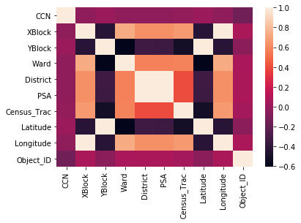

# Appendix

## Scatter Plots

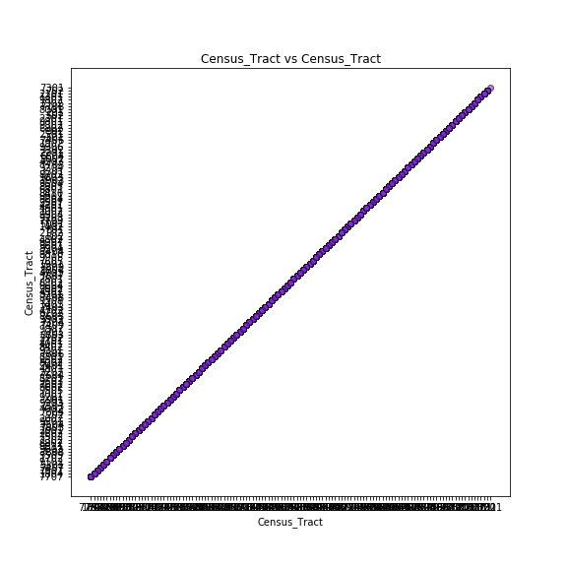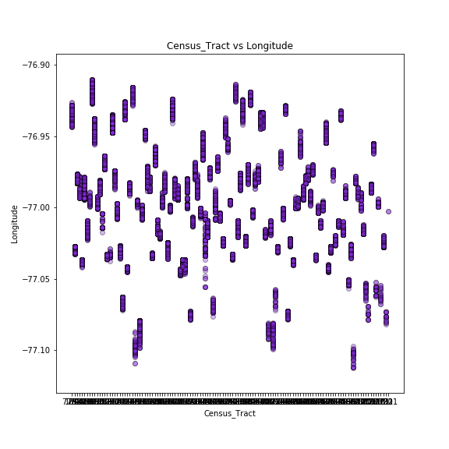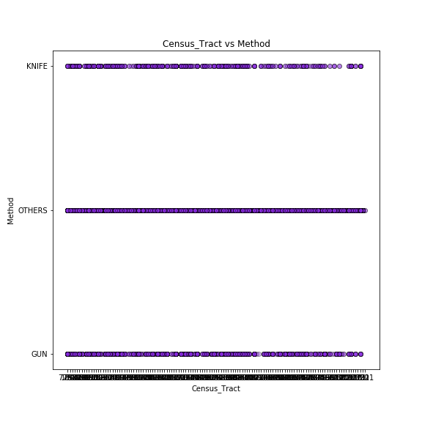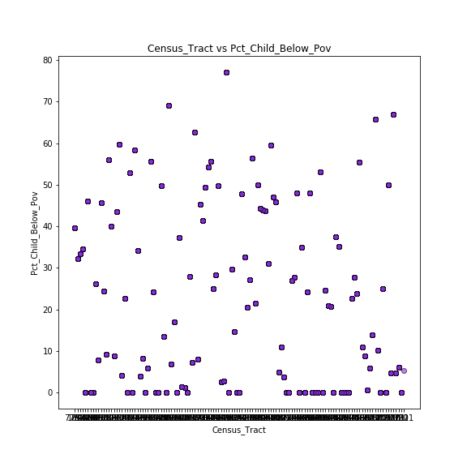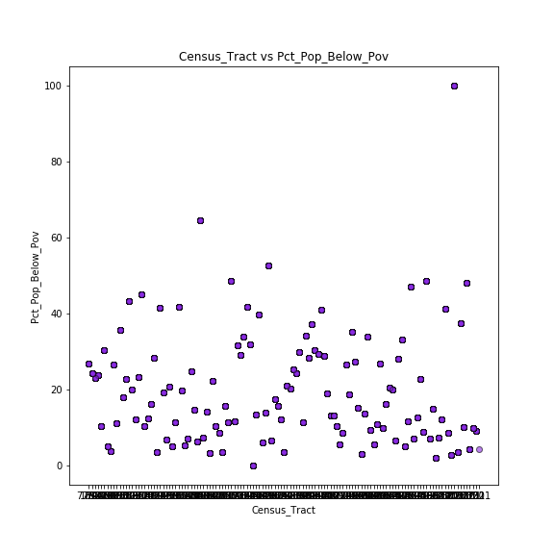

## Histograms

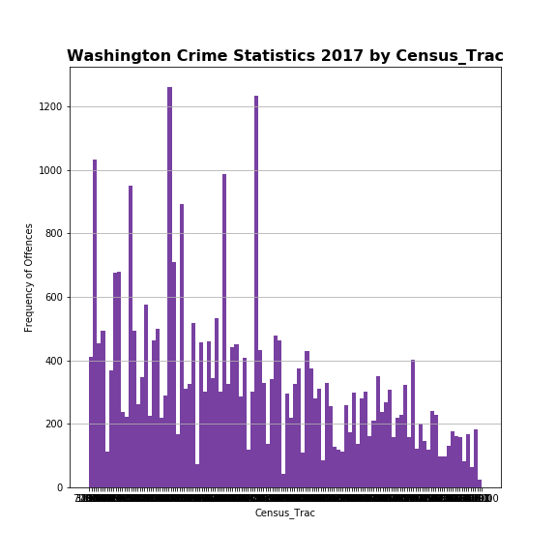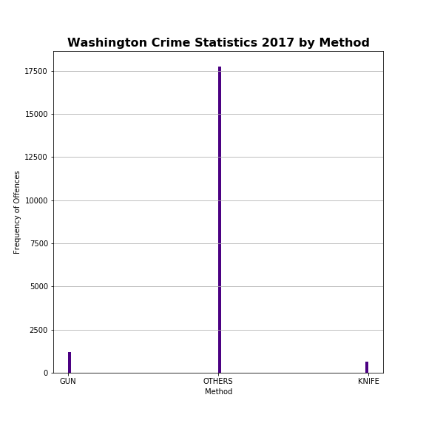

## Heatmap

